Pictured above is the one thing I can remember talking about software wise. Basically it’ll be really useful to be able to find a good way to sleep the device while its not being used to dispense food or communicate to the user wirelessly and or having the user communicate to the device wirelessly.

Don’t know if that’s much helpful. Any details he gave about github, coding was limited and short, better to set up your own meeting with him for questions.

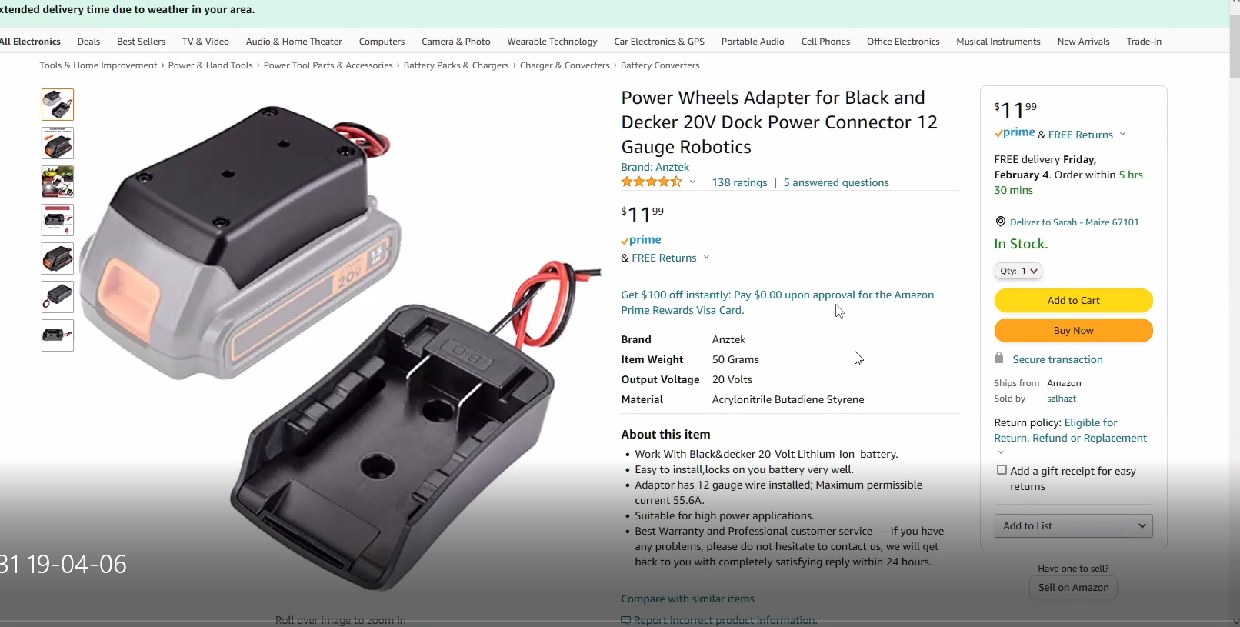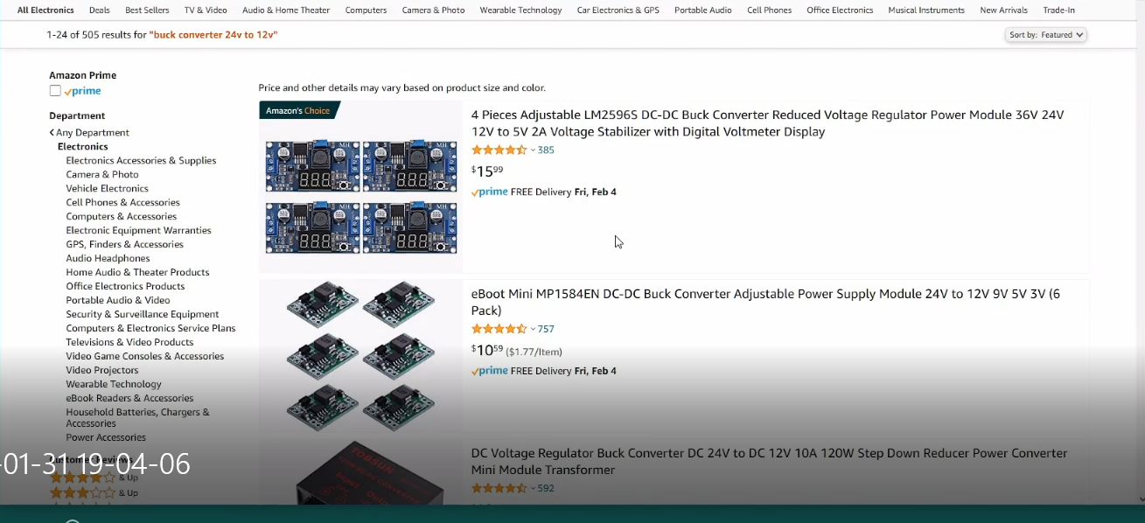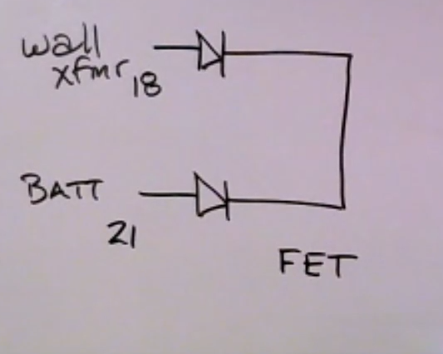

Pictured above is a lithium drill battery and a charging pack. Basically we could use this as out battery and it can recharge too. To step down the voltage of the battery to the left of that is a buck converter which just lowers the voltage and ups the amperage on the output side. We need somewhere between 5v and 12v depending on the final motor. Right now we have the functioning servo but that may not be good enough. Looking for new motor. Keep in mind I have the stepper but couldn’t get it to work. Finally, the last pic is if I wanted a wall XMR like we currently have AND a battery I would need to place diodes to make sure that there wasn’t feedback between components and make the voltage between the two not much different from eachother so as one wouldn’t always override the other. Then a MOSFET could regulate the outputs. Kind of difficult… for me… I don’t want to go this route.

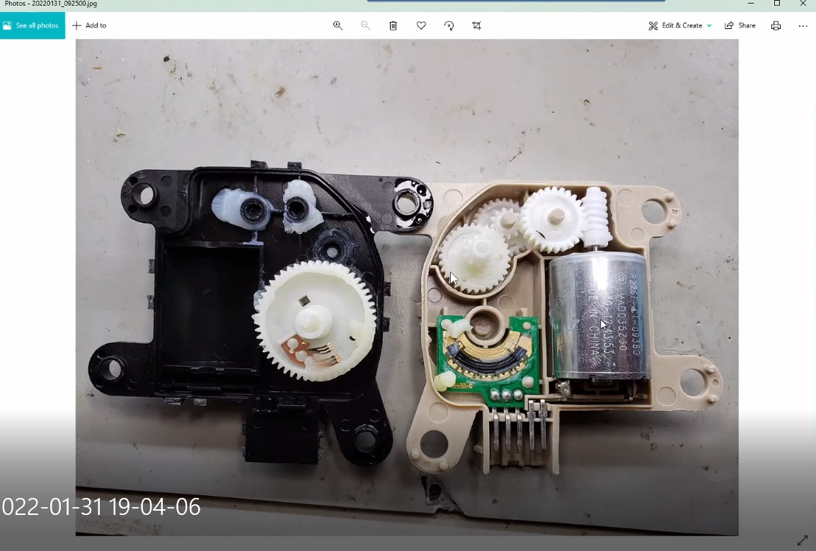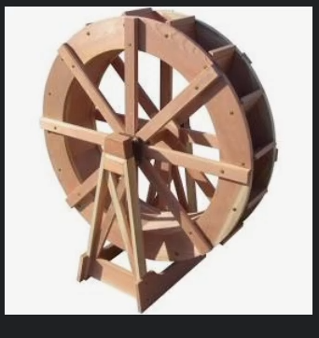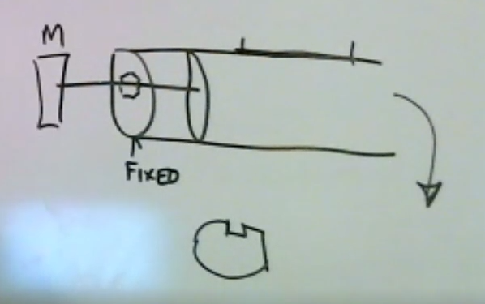

Last three pics are mechanical dispensing ideas from andy. First is a small DC motor connected to cogs that up the torque, like a bike in a way. Second is a waterwheel type dispensing which is hard for me to visualize for our product but I guess food would go into chambers and dispense when moved? Third is one I kinda like: theres a motor that pushes horizontally down a tube and above that is the food container. There would be a door or something that could open and the push would dispense food out the far right. This idea could also be used to turn an auger.

Lastly not pictured is what we talked about last semester where you have a wheel that is turned by a motor… sort of like the waterwheel and it moves food from top to bottom through a PVC pipe or something similar.

Hope this helps a little.